|  |
| --- |
| **MATH AND GAMING**  **21CSS101J – PPS**  **Mini Project Report**  *Submitted by*  **Gauri Gupta [Reg. No.: RA2211026010359]**  **B.Tech. CSE – AIML**  **Mrinalini Vaish [Reg. No.: RA2211026010365]**  **B.Tech. CSE - AIML**  **SRMIST-01.jpg**  **SRM INSTITUTE OF SCIENCE AND TECHNOLOGY**  **(Under Section 3 of UGC Act, 1956)**  S.R.M. NAGAR, KATTANKULATHUR – 603 203  KANCHEEPURAM DISTRICT  **SEPTEMBER – DECEMBER 2022** |

**TABLE OF CONTENTS**

|  |  |  |
| --- | --- | --- |
| **Chapter No.** | **Title** | **Page No.** |
| 1 | Problem Statement | 1 |
| 2 | Methodology/Procedure | 2 |
| 3 | Coding (C) | 3 – 19 |
| 4 | Results | 20 – 22 |
| 5 | Conclusion | 23 |

**PROBLEM STATEMENT**

Every day students face the problem of constantly taking out the average, addition, and subtraction of many numbers. In college, while doing trigonometry they forget basic graphs for trigonometric functions. And after all this, they are very tired and frustrated. To cure this, I developed a code where all these problems are solved where one can easily take out averages of large numbers, can check any trigonometric graph, and can play a minigame to take their mind off from studies.

**METHODOLOGY**

C is a general-purpose programming language that is extremely popular, simple, and flexible to use. It is a structured programming language that is machineindependent and extensively used to write various applications, Operating Systems like Windows, and many other complex programs like Oracle database, Git, Python interpreter, and more. It is said that ‘C’ is a god’s programming language. One can say, C is a base for programming. If you know ‘C,’ you can easily grasp the knowledge of the other programming languages that use the concept of ‘C’. In this mini-project, the concepts of custom libraries, structures, and functions are extensively used. These have made the code easy to read and the use of comments has made it such that anyone can understand this simple code. This is an interactive menu-based program. For the calculation part of given numbers, a new function of arrays was made which made the calculation part of it very simple. For the minigame, I imported a custom library that supported the use of inputting a random number. With the help of this, I was able to make a cool guessing game of numbers. Now for the graph part. I made use of a simple plot function in another custom library and combined them to make a pattern for each trigonometric function. All this code is covered with escape sequences.

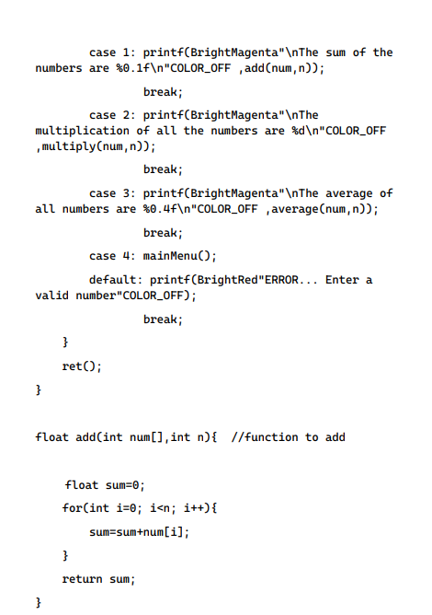

**

**NN NNNNNNNNNNNNNNNNNNNNNN**

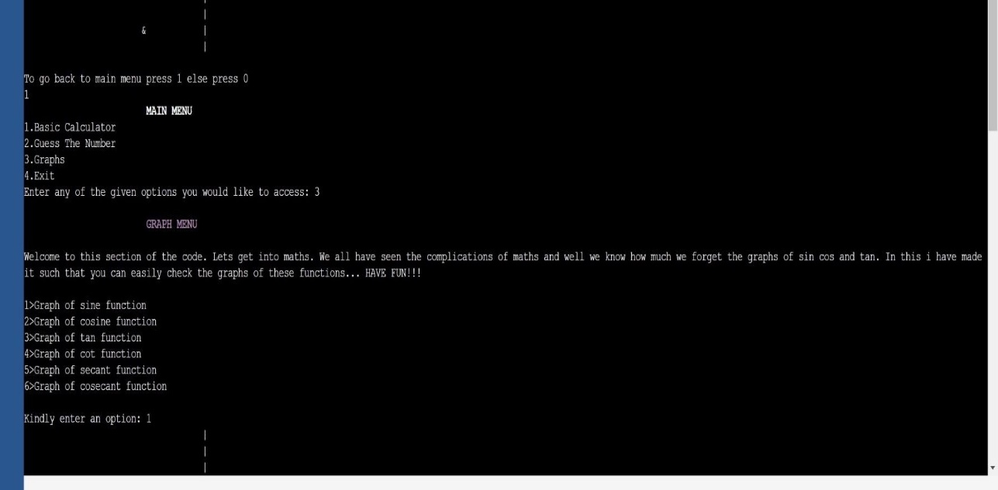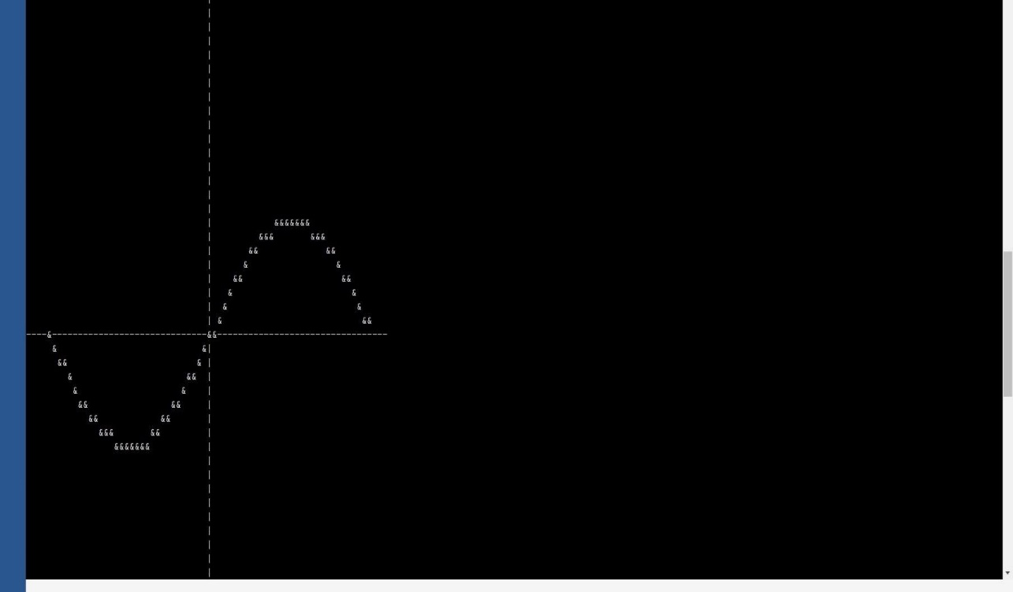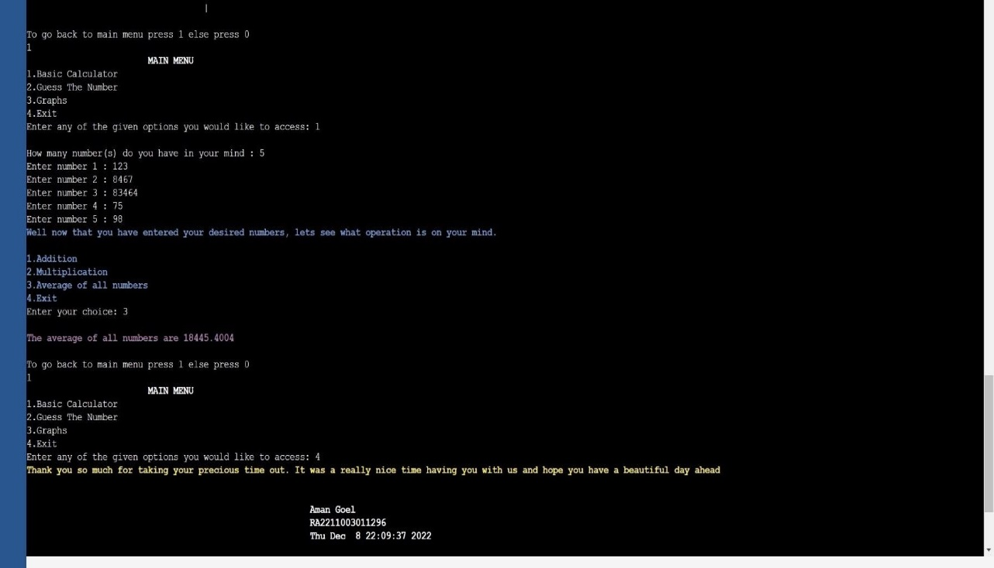

**CONCLUSION**

And hence this code helps students in more ways than one as with the help of this they can focus on their studies as well as can play some games to make their minds fresh. I would like to end this by saying a famous line.

A Little Progress Each Day Adds Up to Big Results…